Supernatural Power-The Communion Service
September 19, 2016
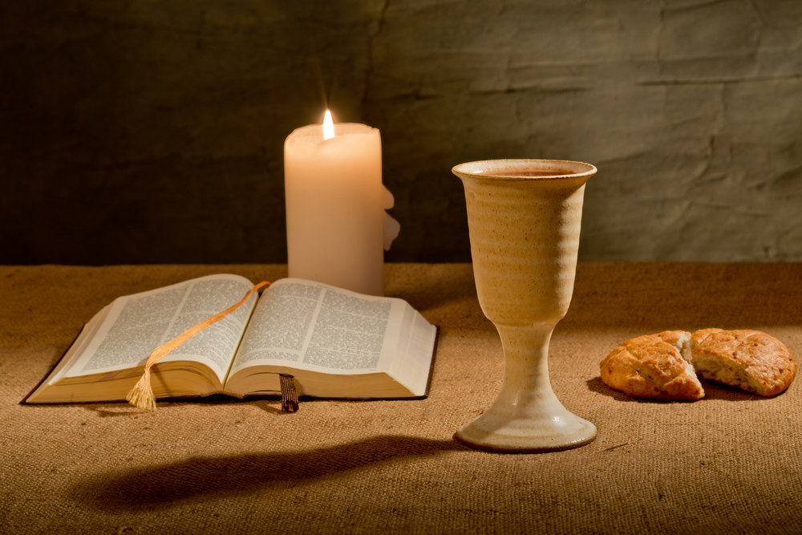
The Lord bless and keep you, Heartdwellers, especially in His peace, with His supernatural strength.

Jesus began speaking to me about a communion service celebrated with great intention, sincerely and focusing on the elements of the service, especially His death and His shed blood and resurrection.

He began, “Do this in remembrance of Me.” And I felt prompted at that point to look up the Scripture.

He took the bread, gave thanks and broke it, and gave to them, saying, “This is My body, given for you; do this in remembrance of Me.” Luke 22:19

And Paul also repeated this,

For I received from the Lord what I also passed on to you: The Lord Jesus, on the night he was betrayed, took bread, and when he had given thanks, he broke it and said, “This is my body, which is for you; do this in remembrance of me.” I Corinthians 11:23-24

Jesus continued, “If only you knew the power of the service worthily celebrated and the gift you’ve been given in it. Watch chains burst asunder, Clare. Watch Me turn tragedy into good, watch Me move through this service. Copious, copious graces flow out from a communion well said. You just don’t know the power you hold in your very hands.

"But the enemy surely does and he makes light of it, to downplay how powerfully it works against him. It looks so lackluster and hidden - yet it's so powerful. However the powers of darkness know what it represents and they make a mockery of it in their own ceremony."

At that point, one of our intercessors called and asked for a special prayer and I felt led to have a communion service for them. They were getting retaliation for all their deliverance prayers for others. They texted me about 10 minutes after I had finished… all the oppressive demons left them, one by one. And the terrible blanket of sorrow and sadness they had been feeling was gone.

Oh, how powerful is the remembrance of Our Lord’s sacrifice on the Cross!

Jesus continued, “There is no force on Earth that can trump communion said with earnest faith and deep remembrance of My Passion. What I have given you, Clare, is far more powerful than even the words that come from your mouth. The intension of your heart, covered with the blood of sorrows from My death and resurrection, contains all that is necessary to defeat evil.

"It is so simple, so uncomplicated, yet so very prodigiously powerful. You, My love, must get rid of this ambivalence about its efficacy.
"There’s an agony that goes on in Heaven when a communion service is said with great reverence and focus on My Passion. It is like a shiver that passes through everyone as it goes to the throne, touching each like a minuscule bold of lightening. It’s a current of remembrance and graces come swiftly pouring out from the Throne Room. Like a shock wave, flipping a switch that opens the doors of grace.

"Clare, what I did on the Cross will never, ever be forgotten, because God Himself allowed man to crucify Him on that day. And spoke the words, “Do this in remembrance of Me.” This indeed was the finished work of the Cross. To recall My suffering on that day sends this shiver through all in Heaven. Never underestimate the power of that shiver, for all in Heaven understand what it was about, even more than you who are still on Earth. It penetrates the gates of grace and they open to shower graces upon those needy and crying out.

"Remember this, Daughter. Pray these prayers with great intention and reverence, and behold the transformations that will come as a result. Not only within you, but also with those you lift up in the service.

"Go now and elevate this practice to the place of greatest dignity and power. Surely, I will bless all who celebrate it worthily and harken to their petitions."

And that was the end of His message.

And I just wanted to share with you that we have a video about having a communion service at home, a very simple way to celebrate it. And I receive the Lord every day in the holy, consecrated bread and wine. Every single day I receive Him. I have consecrated hosts set aside, so that I can receive without having a full communion service.

So, it's very, very important. And it was amazing that I got texted immediately after the service, all these demons just disappeared, one by one. And how the terrible blanket of depression just evaporated.

So, dear Heartdwellers, use our website search engine about communion, and it'll take you to the videos that are about communion. And that'll help you get an idea of how to go about it. If you're new to the Channel, that is. And for all of us who've been here with us full-time, we need to understand that this is a highly, highly honored practice and grace. And it can be used to break all kinds of manifestations of evil.

So, let's put it in its rightful place and use it. This is a great gift that He's given us and is definitely a weapon that the enemy fears, and that's why he puts it down and minimalizes it.

Thank you for listening in, thank you for your prayers. And thank you so much for your support. We love you!

